PART 1

* Checking the software requirements

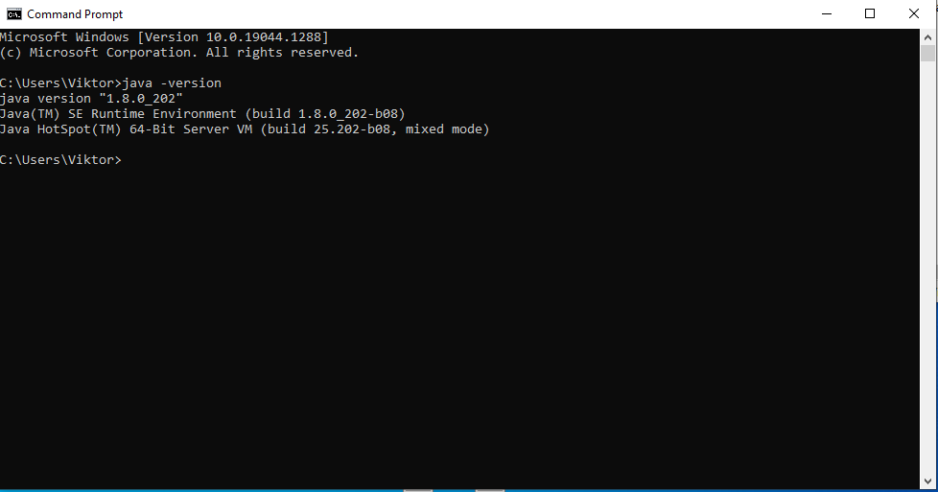

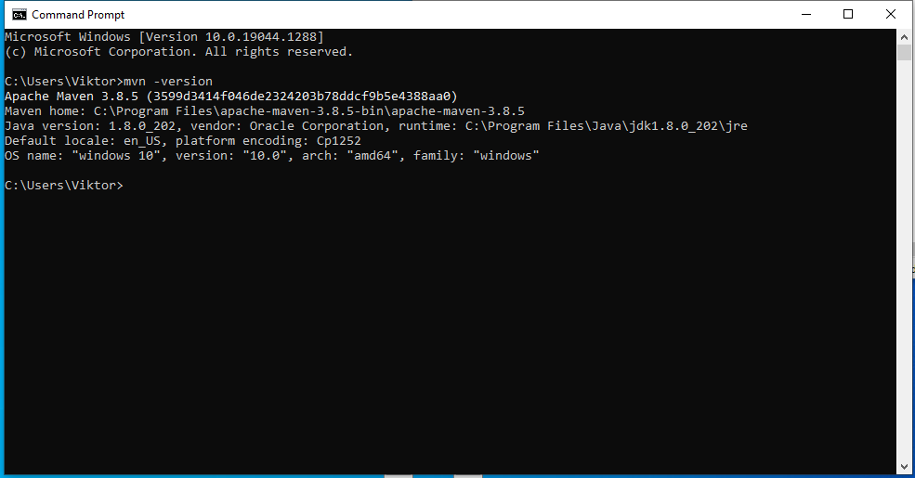

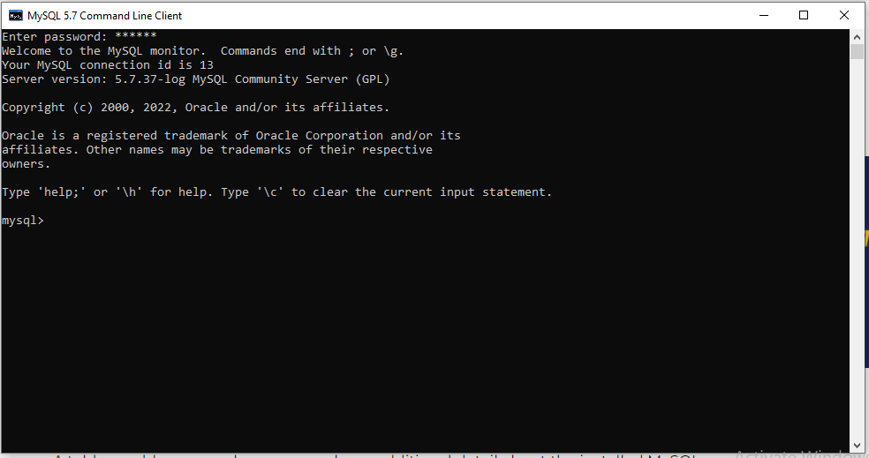

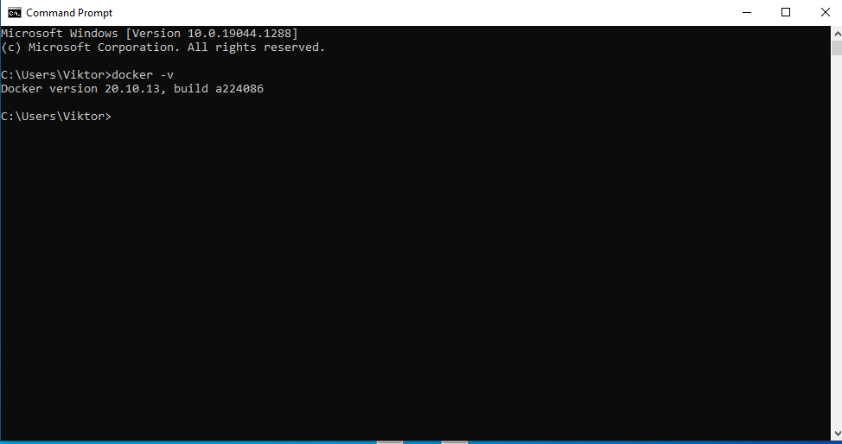

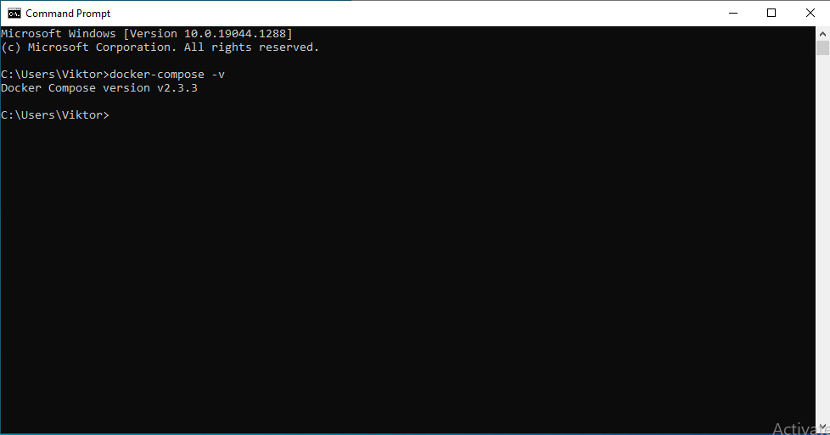

* Build the app

First step is creating the .jar file

I was using the following command: mvnm package -DskipTest

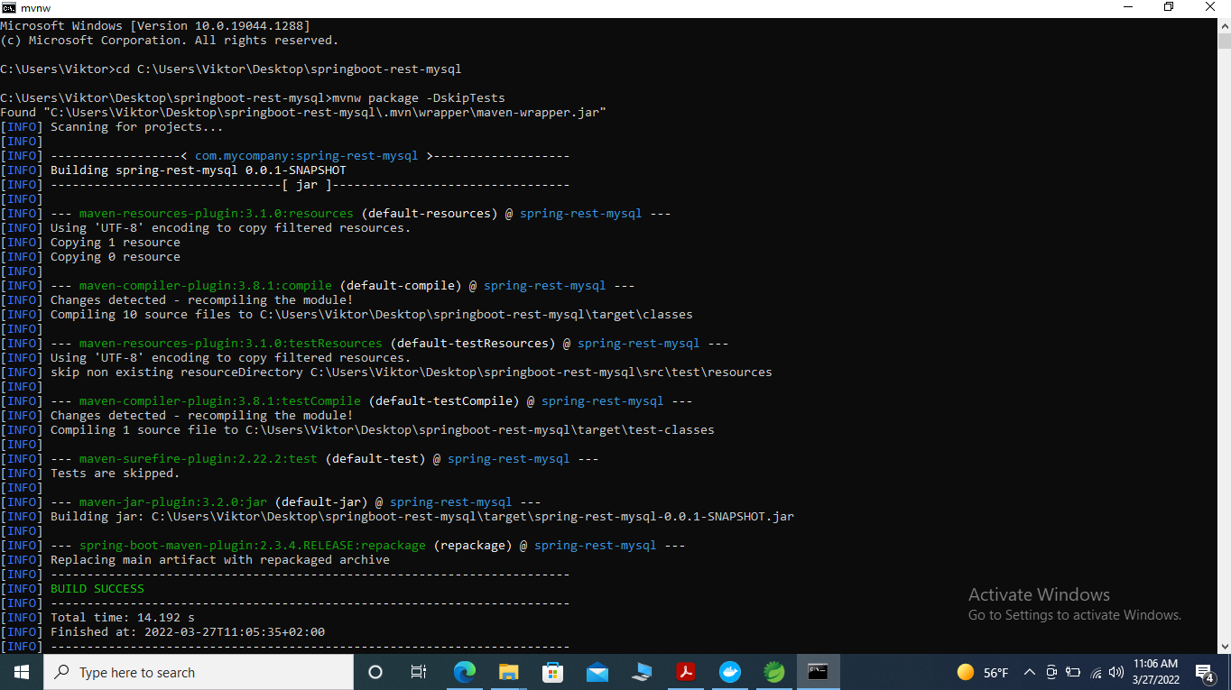

Next step is importing the spring boot application in STS tool, creating Dockerfile, creating an image and container:

At the beginning, there is no image in the Docker:

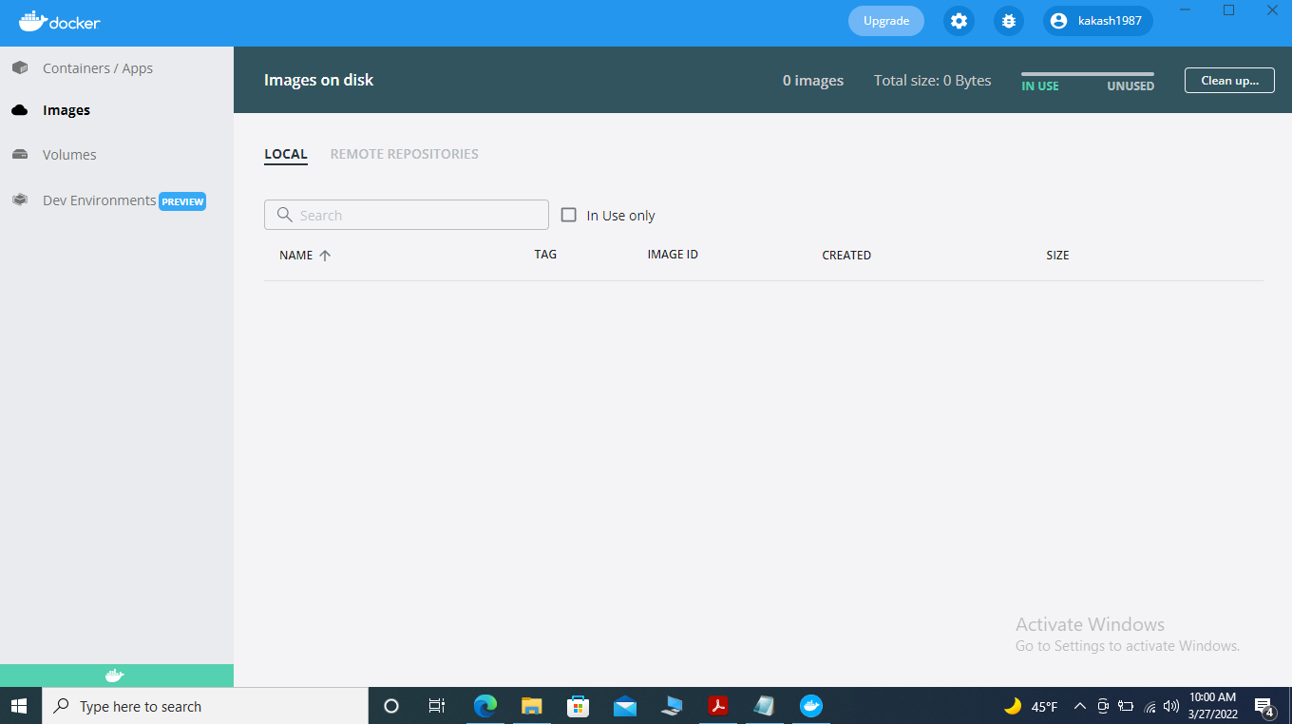

I create a Dockerfile, using the following commands:

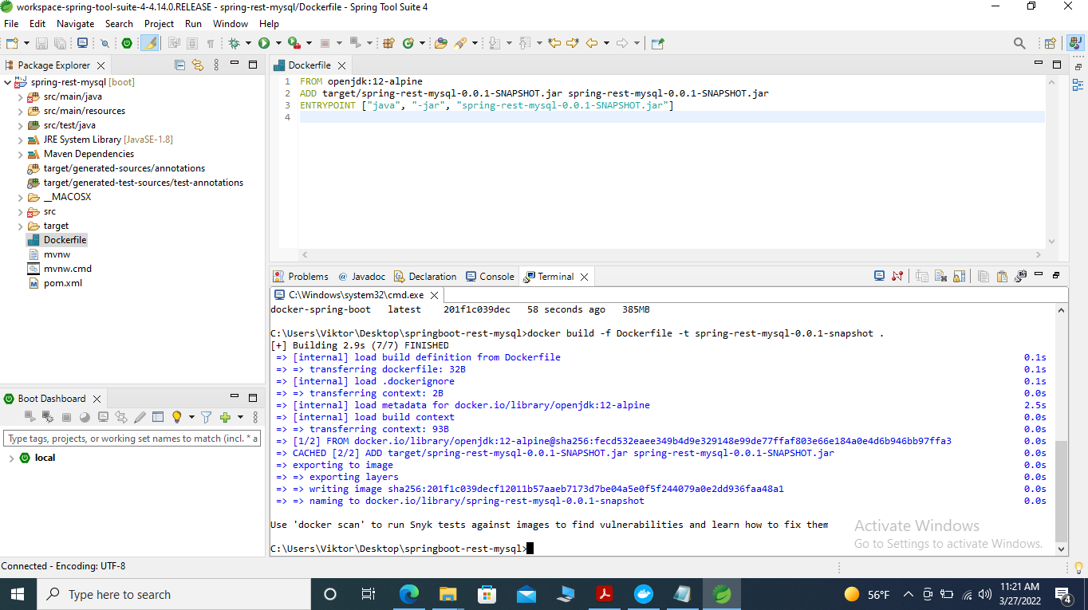

The image creation confirmation:

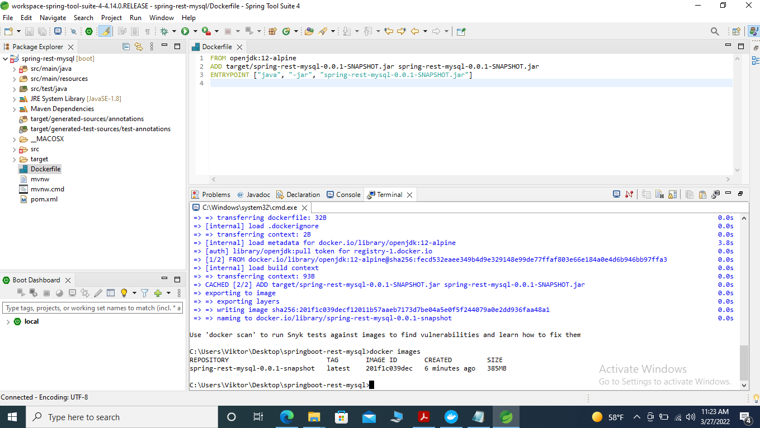

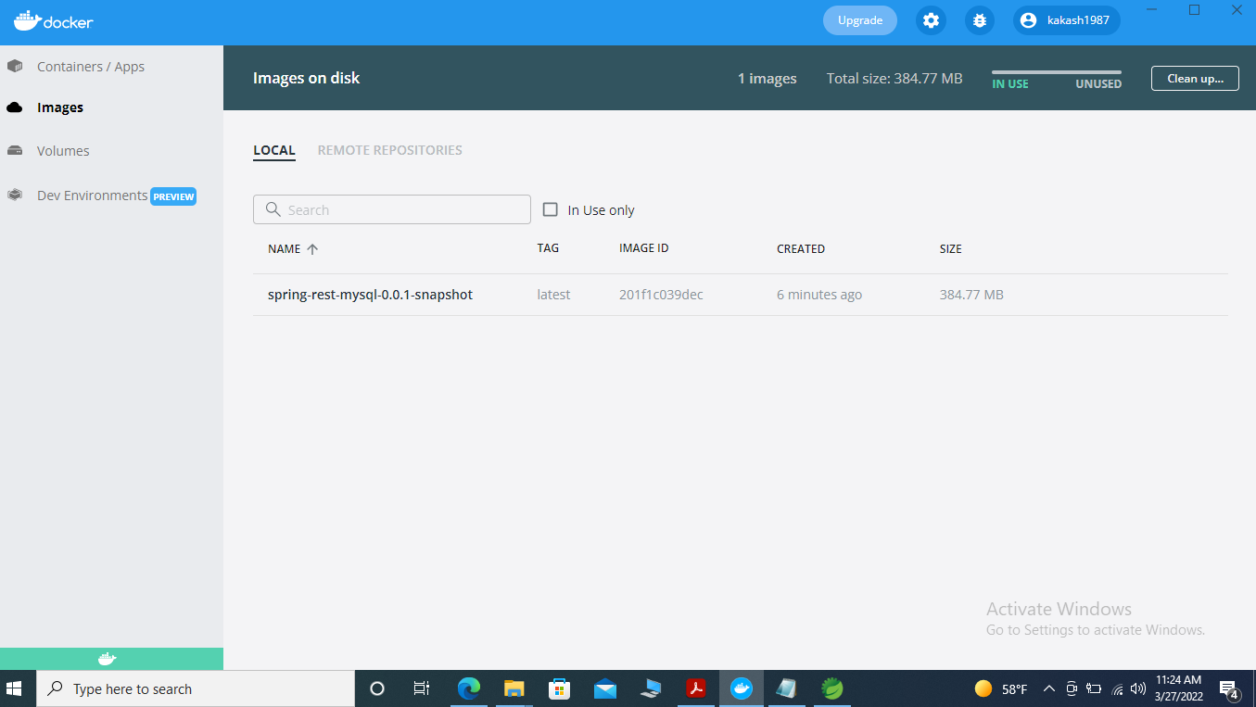

The next step is container creation using the following command:

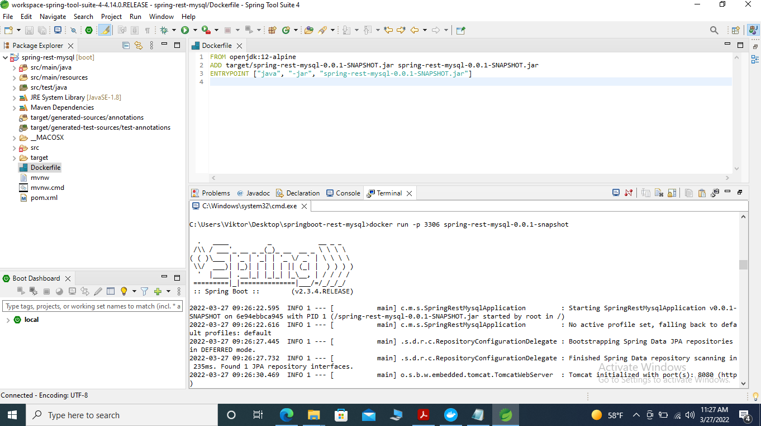

The container creation confirmation:

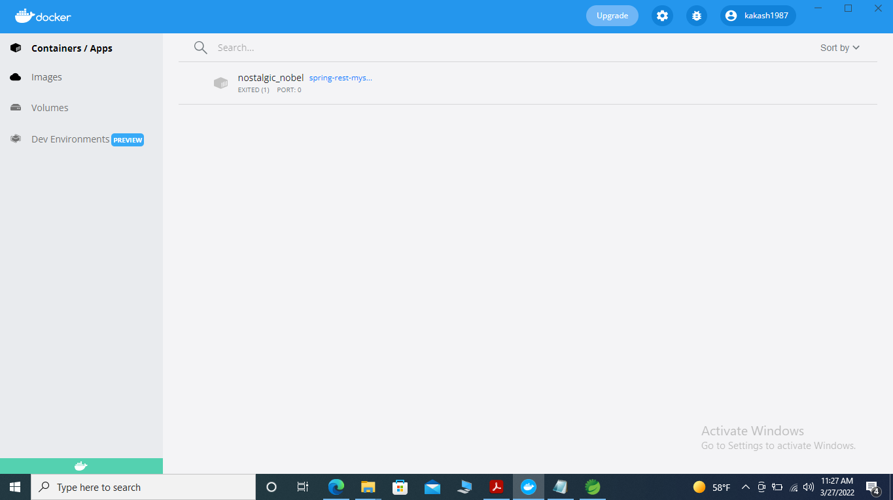

PART 2

The first step is to create docker-compose.ymlk file with two services

version: "3.8"

services:

mysql:

image: mysql:5.7

restart: unless-stopped

volumes:

- db:/var/lib/mysql

environment:

-MYSQL_ROOT_PASSWORD: root

-MYSQL_DATABASE: test

-MYSQL_USER: spring_user

-MYSQL_PASSWORD: secret

ports:

- 3306:3306

app:

image: spring-rest-mysql-0.0.1-snapshot

depends_on:

- mysql

build: ./multy-stage-example

restart: on-failure

ports:

- 8080:8080

environment:

-url: jdbc:mysql://mysql:3306/test

-username: spring_user

-password: secret

volumes:

db:

After testing the file using docker-compose config command, and docker-compose up –d command for starting, we can see the result on the the pictures bellow:

